CABT says that what you choose to think determines what you feel, and you choose your behaviors from what you feel. CABT recognizes that your brain has two different ways of thinking. The left brain is logical, systematic, and thinks in words and numbers. While the right brain thinks in images and pictures.

The Need For CABT: Back in the late 1960s there became an awareness that something was missing from recognized therapeutic approaches. A review of the literature revealed that all therapists use an approach that works in one or a combination of three ways: Cognitive, Behavioral, and Feelings.

Freud used basically a cognitive approach. The goal was to help the client understand the source of his problem. "What did your mother do to you that made you this way?" Skinner, the behaviorist, stuck close to behavior modification techniques. Carl Rogers with his unconditional acceptance approach focused on the client feeling safe so that clients could focus on their feelings. Fritz Perls with his Gestalt therapy tended to use more of a combination of cognition and feelings. While Albert Ellis used a cognitive–behavioral approach.

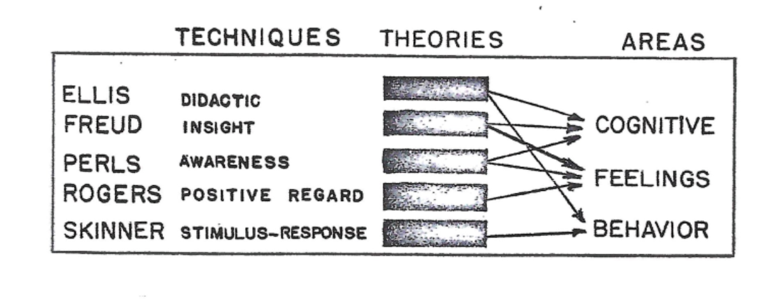

CABT is a combination of Cognitive > Affective > Behavioral Therapy focusing on how your brain has two different operating systems when it comes to processing inputted information. There is the cognitive side of the brain (often referred to as the left side of the brain) tends to use a logical, systematic, rational approach. For example, 1+2 = 3. Unfortunately, sometimes our brains are fed false, illogical, irrational, or contradictory input. Such as, “If you cannot do a job right, do not do what it all.” Versus the contradictory statement, “If at first, you do not succeed try, try again.” The left side of the brain is very much like a computer, “Garbage in, garbage out.”

A left-brain therapy would focus on “kinky thinking.” This approach can be found in the book Feeling Good by David Burns.

The other side of the brain, often referred to as the right brain, inputs and processes information differently—this side of the brain inputs information from memories stored as pictures. When the right brain accesses one of these stored memories, it sees the picture not as something that happened days or years ago but as something that is happening right now.

If it is a pleasant memory, such as relaxing on a quiet beach, the body will tend to return to that state of relaxation when you were at the beach. On the other hand, if the memory is of a traumatic incident where you lost one of your buddies and maybe your leg, then when your right brain retrieves that picture, your body will return to a state of anxiety, fear, and powerlessness. When this happens, it is often diagnosed as Posttraumatic Stress Disorder or PTSD, and you are said to have had a “flashback.”

How is CABT different?

1. Research has demonstrated that each one of these approaches works for some patients to help them achieve the desired changes. At the same time, CABT utilizes all three cognitive, cognitive, and behavioral change elements.

2. While most therapeutic approaches focus on one or two cognitive, affective, or behavioral, CABT focuses on all three therapeutic areas.
3. CABT uses both right and left-brain therapeutic approaches, depending on which method the patient is amenable to, such as CBT, Person Center, or Freudian therapy.
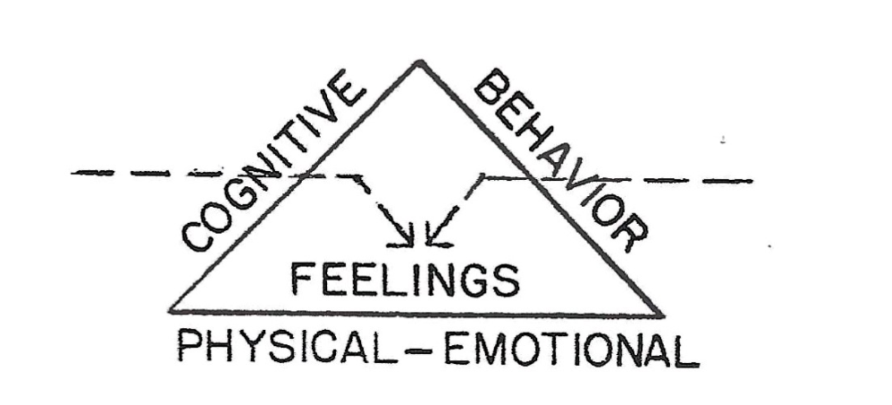

We know now that unless there is a permanent change in the person's feelings, there will be no permanent change in the behavior.

Between the right and the left brain, the brain processes all the information you know about people, events, and words (which is everything there is). As a result, the mind may experience contradictory emotions. Anyone whom a dog has ever bitten may know logically that most dogs are safe and friendly BUT may still have a strong visceral reaction when confronted with the most domicile of dogs.

We do not react to people, events, or words but to what they mean to us, and we choose the meanings. This thinking, for most people, is done unconsciously. You assume that words mean whatever the dictionary says they mean. Not true! You will never find the meaning of words in the dictionary.

The dictionary only has the definition of words. Something happens, someone does something, nature does something, or words are said; you will then put a meaning, belief, or expectation on what occurred. The result is, depending on thoughts that you think you place judgments on what happened or what was said, you now have feelings based on these judgments of the situation. Now, consciously, or unconsciously, you will choose your behaviors.

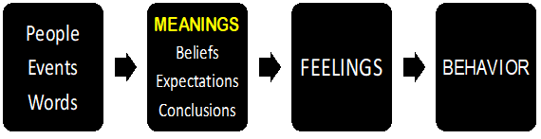

Words have no meaning; only people have meanings.

Most people are not aware that they think! They believe that they are the victims of thoughts not the producer of thoughts. Albert is depressed. Albert is depressed because he believes the world is overwhelming. The world is not overwhelming only what Albert believes about the world makes him feel depressed. If you change what you think, you will change what you feel.

“You feel the way you do right now because of the thoughts you are thinking at this moment.” David Burns MD, Feeling Good

What meaning do you choose to put to this sentence, "In fifteen years of marriage, I have never seen anyone that I would rather be married to than you." Is the person saying they have been looking for someone else for fifteen years? That is the meaning that one wife put to what she heard.
You choose to think, and you can think anything you want to think. Thinking is what you do to create reality. A word is nothing more than a vocalization, or sound, to which you give meaning. As human beings, you make or invent words and then put the meanings onto your words. In turn, the words create your feelings.

"Men are not disturbed by things, but by the view they take of them." Epictetus 55–135 AD

The right brain thinks using pictures, smells, and textures. The right brain is not logical and believes that what it "sees" is real and is happening now. Flashbacks and nightmares are experienced on the right side. This side of the brain learns through positive and negative emotional experiences, such as trauma.

This StimulusàResponse (S-R) type of learning leaves "pictures" on the right side of the brain, which can be re-experienced as flashbacks and panic attacks.

The left and right sides of the brain contain meanings it has gathered over the years. However, one of the significant differences between the two sides of the brain is that the right side of the brain is not logical because it sees in pictures; therefore, it cannot be talked out of what it sees. Meanings are stored in either the right or the left brain.

MEANINGS include ***
Thoughts, Judgments, Beliefs, Expectations, Fears,
Conclusions, Decisions, Values, Anxieties,
"Shoulds" (I, You, & It)

In contrast, the left brain will attribute meanings to people and words. These can be changed relatively easily with more updated and correct information because it operates like your computer. You can change the information on a computer without it becoming emotional. This is not so with information stored in your right brain because that information is stored in pictures.

For some people, dogs, snakes, spiders, rats, and even rabbits can be scary and create instant revulsion. At the same time, your left brain says, "Don't be silly. That little dog cannot hurt you."
When I hear someone say, "I understand, that makes sense, but. . .." That is when I know that person has different and contradictory meanings in the two sides of their brain. Their left side is telling them one thing, and their right side is saying the opposite. All my logical and cognitive arguments will not affect helping them to change.
This is a problem with the Freudian insight therapy approach. Having insight into what caused the problem does not help a person change when the right brain presents a different "picture."

Examples
On the logical left brain, you often encounter why questions; these “why” questions will seldom lead to change. Why questions usually make people defensive, and then the person starts looking for rationalizations.
"I am this way because I was abused as a child, my parents divorced, and I felt abandoned." Having a logical (left-brain) understanding of how you got to be the way you are will seldom help you change your unwanted fears and behaviors.
You experience feelings either from the meanings in the left side of your brain or on the right side. You may fear certain people or groups of people because you have been told that they are dangerous (left side of the brain) or you may experience fear because you got shocked when you put your finger in a light socket (right side of the brain)! If you change either your right brain or left brain you can change your meanings, and you will change your feelings.
If your problem is strictly a left-side cognitive issue, then fairly easily you will be able to change your faulty belief system.
For example, If you believe that garbage is what people reject, you get to feel valueless when you are dismissed. But if you bid each your belief to one that says people reject things because they cannot see their value, the problem is in the person rejecting them.
However, if your belief about rejection is coming from and personal experience where your father took you to the city dump to get rid of your beloved pet dog. And your last memory is looking out the back window and seeing the dog chasing after the car. All the logic in the world is not going to help you change that picture.

Feelings directly result from what you think and the intensity of what you have experienced. Every feeling can have more than one belief and pictures to support it. For example, the world is not safe, and I am not safe in this world. Experiences from childhood, high school, college, and war can all provide “evidence” that the belief that the world is not safe is true. The more traumatic experiences that you have will increase the PTSD symptoms that you experience.
There are three levels of feelings. For example, when confronted with a very angry barking dog your first-level feeling will be fear of that dog. Later that fear may grow into the fear of all dogs and a sense of anger at the neighbor for not controlling his dog. This can turn into a feeling of powerlessness and feeling like a victim.

FIRST-LEVEL FEELINGS ***
Below are listed some of the beliefs, and meanings that can create your first-level, feelings. The meanings that you put on events determine what you feel and create your first level of Feelings. . .

MEANINGS à RESULTS IN à FEELINGS
"I'm in danger." à à à Fear
"I did wrong" à à à Guilt
"I'm bad." à à à Shame
“I can’t” à à à Powerlessness
"I should (you, it) à à à Disappointment
"Nothing to do" à à à Boredom
"My mate left me." à à à Loss
"I'm not important" à à Discounted
Contradictory Beliefs à à Confusion
All these beliefs can originate through either a right-brain experience or being told by someone, a left-brain experience.

SECONDARY FEELINGS ***

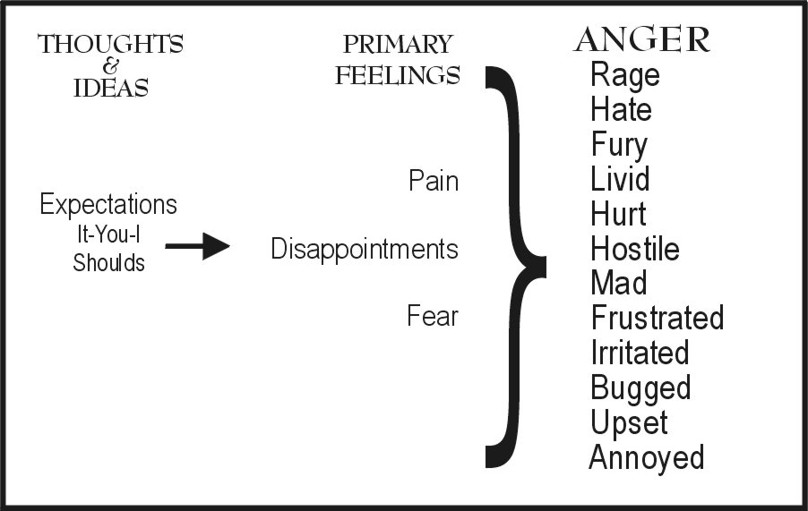

Anger is a secondary feeling (you always feel some other feeling before you feel angry). Anger is the "energy" designed to change the environment and yourself and reduces primary feelings. Anger comes in degrees from mild to intense: Annoyed, Irritated, Upset, Frustrated, Disgusted, Mad, Hostile, Hate, Livid, Furious, and Rage.
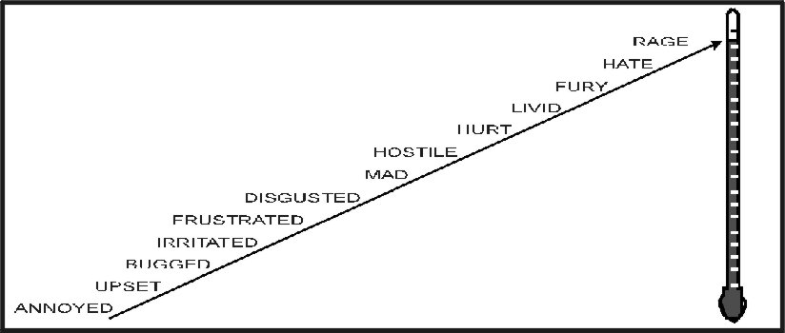

There are three uses of secondary anger. 1. Rejection, most people think about using anger to reject someone or keep them out of their lives forever. Of the three uses of anger, using anger to keep someone out of your life forever is the one that is used the least often but is assumed the most often. This is because most people do not realize that the opposite of love is not hate or anger. You get angriest most at the people you love the most!
The opposite of love is indifference; it is not anger or hate (strong anger). If you cannot get angry at the one you love but have indifference about what he/she does, you have indifference, not love!
2. Manipulation, second-way anger is used. It is the one most often employed. Using one of the degrees of anger to manipulate someone is not necessarily bad. Yelling at a child to prevent them from running in the busy street or to prevent them from touching a hot stove is an act of love. The wife who yells at her husband for being a workaholic, "I didn't marry you to have you working all the time," expresses the desire to have a closer and more intimate relationship. However, he may not experience her anger as love. It depends on how she says it.
3. VENTING, expressing anger without the expectation of changing someone, is a way of reducing the energy that builds up in you after a frustrating day. The rule is, "Feelings expressed verbally, as intensely as they are felt, will take place and are free to change." If you do not find relief after venting, then it is important to see if you have "tied" your feelings to the behavior of the one with whom you are angry. In this case, you will find yourself staying angry until that person changes their behavior to match your expectations!
Being angry is not a problem. Nobody has ever gone to jail for being angry. It is how you express the anger that gets you into trouble!

THIRD LEVEL FEELINGS ***
Many people see anger as negative and bad. As a result, they will lie about being angry, "I'm not angry; I'm just upset!" These people often see anger as a sin. IF anger were a sin, then you lied about it, would not that be sinning twice?
The result of denying and repressing your anger was identified by Freud over a hundred years ago when he pointed out, "Depression is anger turned inward."

DEPRESSION IS ANGER WITHOUT ENTHUSIASM!

Notice that you are choosing to be depressed because you are choosing not to be angry. You cannot be yelling, screaming angry, and depressed at the same time. What you can do is be angry and attack someone with putdowns, name-calling, and threats. Then you get to feel guilty and stuff your anger again. This will result in the buildup and blowup syndrome, which adds to depression and feelings of powerlessness.
Other third-level feelings include anxiety, resentment, bitterness, apathy, and boredom. Third-level feelings are not a fun place to be. So now the question becomes, what are you going to do with these feelings?

BEHAVIOR ***
If you wait until your feelings have reached the third level, then your options are limited.
Get Even: I once saw a sign that said, "I don't get angry; I get even." This type of passive-aggressive behavior is a way of expressing anger, which is guaranteed to make your relationship worse.
Passive-aggressive people are afraid of the anger and see it as dangerous. They usually have come from families where anger between mom and dad was never expressed openly. For these people, it is the fear of the unknown. Or they come from families where anger was expressed as verbal or physical abuse.
Get Sick: Depression is not just an emotional state. When you are depressed, your whole body's immune system is depressed. People who are depressed are more susceptible to colds, flu, and other physical problems. Years ago, our County Hospital in Fresno, VMC, was part of a national research study that found that over 60% of cancer patients reported being depressed for a period of 6 to 18 months before developing cancer. Depression can repress the immune system.

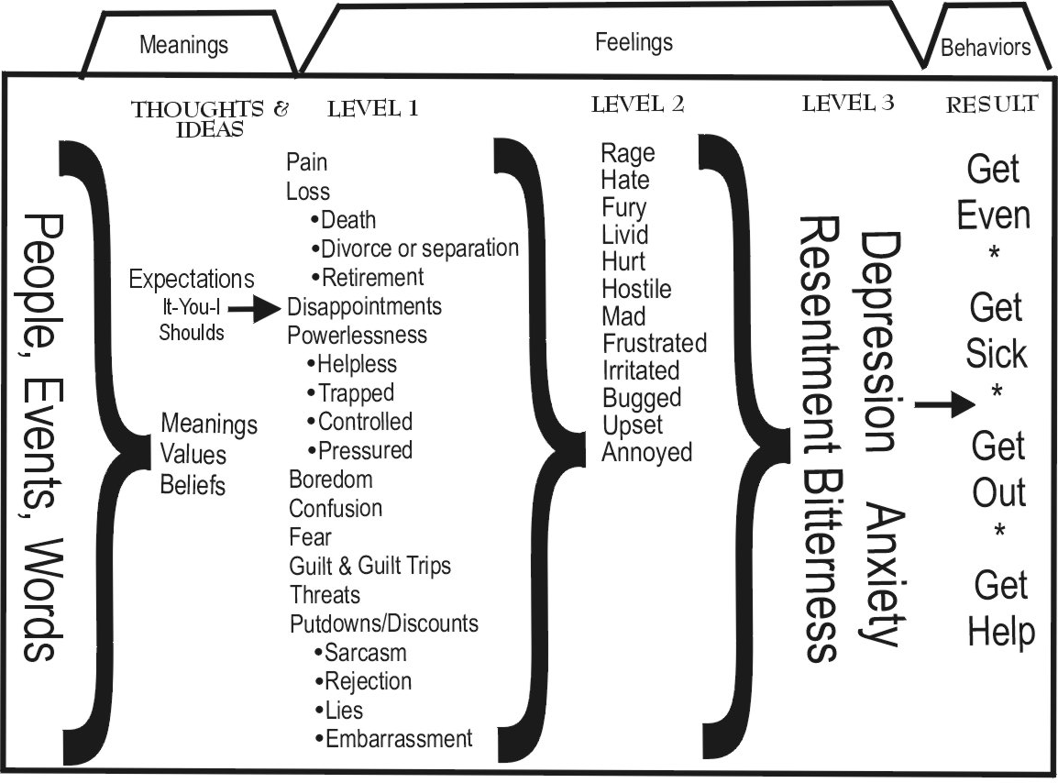

Get Out: Nobody enjoys third-level feelings, so other options are soon being employed. These will include fighting. Then, when nothing changes, the person moves on to withdrawing and finally to divorce or suicide.
Now, I know none of these options seem like good choices. So, I will offer you a radical idea that you might consider when all else fails.
Get Help! When to get help for your anger and depression:
- If you have a long list of "I Shoulds", you will be depressed. Then you may want to get some help. The longer your list of "I shoulds," the more depressed you will be.
Not one of your "I shoulds" is yours. If the “shoulds” were yours, you would be doing them. It is possible to live without a single "I should." To live “should free” will require that you trust yourself that if you are not doing your should, then you really did not want to do it, and that is okay.
- If you are in a relationship where nothing is getting solved. There is help. What are you willing to risk to get the changes you say you want? Since the only person you can change is yourself, are you willing to change your expectations? Are you willing to get a divorce?

You Shoulds: When you reach this stage in your relationship, you might consider your “You shoulds.” “You shoulds” are your expectations for someone else. In most relationships, the problem has to do with people not living up to your expectations. “She should do what she is supposed to do, and then I would not be so upset.”
Do you believe that people should do what you think they should do, not what they do? Where did you get that belief that people should live up to your expectations?
It is okay to have expectations if you remember that the only person you can change is yourself!

If you have a lot of “I shoulds” you will make yourself miserable.
If you have a lot of “You shoulds” you will make everyone else miserable.

- When you are sick and tired of being sick and tired and want to change. Depression is an option. Or
- you can choose to get help. You can choose to feel alive! Which will you choose?

Myron Doc Downing PhD
Specializing in Building Relationships, Depression,
Anger Management & Anxiety Disorders

Contact Myron Doc Downing Ph.D. at:
Email: docdowning103@gmail.com
Website::DocDPhD.com

